**DIPO PREPARATION PROCESS USING SDLC FRAMEWORK**

**Name: Erasmus E Obeth**

**Registration Number: U17CO1017**

**State of Origin: Gombe**

**Local Government Area of Origin: Billiri**

**Native/Local Dish: *Dipo***

1. **Requirement Gathering**

In this phase, the necessary user need stakeholders, ingredients, budget and equipment needed to prepare ***Dipo*** were researched, understood and compiled.

**Identify the Stakeholders:** The cook and the people who will be eating the Difo.

**Define User Needs:** The ***Dipo*** should be cooked thoroughly, have a soft and enjoyable texture, and have the desired taste based on personal preferences for spices and texture.

**Ingredients and Nutritional value:**

**Estimated Cost and Quantity**

|  |  |  |  |
| --- | --- | --- | --- |
| Ingredient | Quantity (Tier) | Price per quantity (Naira) | Nutritional value |
| *Bambara nut:* | 1/4 | 1000 | protein, fiber, minerals (iron, magnesium) |
| *Maize:* | 1/2 | 1200 | carbohydrates, fiber, vitamins (B vitamins), and antioxidants |
| *Beans:* | 1/4 | 800 | protein, fiber, and essential nutrients like folate and iron |
| *Groundnut or Benniseed:* | 1/4 | 1000 | fats, protein, vitamins, minerals (vitamin Magnesium). |
| *Potash:* | 3 table spoon | 50 | None, catalyst |
| *Salt:* | 3 table spoon | 20 | Enhance flavour, sodium (for fluid balance in the body) |
| *Maggi/spices* | Depending on taste buds | -800 | - |
| *Equipment’s:* | - | -rental 2000 | - |
| ***Estimated Total*** |  | **6870 => 7000** |  |

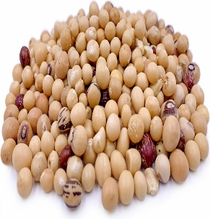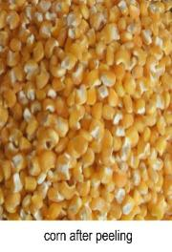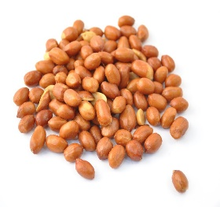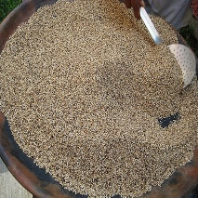

*Groundnut*

*Dehusked Maize*

*Bambara nut*

*Beans*

*Benni or sesame seed*

**Equipment:**

Pots Grinding equipment Frying utensils Stirring Spoon,

Knives, Chopping Board, Cooking Utensils Bowls

**Time Management:** Average 6 hours preparation time  
 Average 2 hours cooking time  
 Total time average to deliver food 8 to 10 hours

**2. Feasibility Study**

Evaluate the feasibility of preparing Dipo by assessing the availability of ingredients and the required cooking facilities.

1. Ensure all ingredients are available in the required quantities.
2. Verify that cooking equipment and utensils are adequate.
3. Estimate the total preparation and cooking time to plan the process efficiently.

**3. System Design**

Design the process flow for cooking Dipo, detailing each step from preparation to serving.

1. Dehusk the maize.
2. Soak bambara nut and maize overnight.
3. Heat water in a pot.
4. Add soaked bambara nut to the hot water.
5. Cook for 45 minutes.
6. Add soaked maize.
7. Cook for 60 minutes.
8. Add beans.
9. Cook for 35 minutes.
10. Add potash.
11. Monitor water levels and add more as needed.
12. Taste and adjust for desired softness.
13. Remove from heat and transfer to a bowl.
14. Fry groundnut or benniseed until dry and brown.
15. Grind the fried groundnut or benniseed.
16. Mix groundnut/benniseed with cooked Dipo.
17. Add salt and dry spices.
18. Mix thoroughly.
19. Serve and enjoy.

**4. Software Design**

Translate the process flow into detailed instructions for each step.

1. Dehusk Maize: Remove the outer shell from the maize kernels.
2. Soak Ingredients: Soak bambara nut and maize in separate bowls for (minimum 6 hours maximum 8 hours.
3. Heat Water: Put water in a pot on the fire and heat until close to boiling.
4. Cook Bambara Nut: Add soaked bambara nut to the hot water and cook for 45 minutes.
5. Cook Maize: Add soaked maize to the pot and cook for 60 minutes.
6. Add Beans: Add beans to the pot and cook for 35 minutes.
7. Add Potash: Add a small amount of potash to aid in cooking and softening the mixture.
8. Monitor Water Levels: Add water as necessary to prevent burning.
9. Taste for Softness: Ensure the mixture is cooked to the desired softness.
10. Combine Ingredients: Remove from heat and transfer to a bowl.
11. Fry Groundnut/Benniseed: Fry until dry and brown, then grind.
12. Mix Ingredients: Combine groundnut/benniseed with the cooked mixture, add salt and spices, and mix well.
13. Serve: Serve in a plate or bowl with water, dried pepper, and additional spices as desired.

**5. Coding**

* **Execute the Steps:** Follow the step-by-step process, to cook Dipo designed in the previous phase.
* **Monitor and Adjust**: Monitor the cooking process and make necessary adjustments to taste and consistency.

**6. Testing**

• **Taste Test:** Sample the dish to ensure it meets taste expectations of softness and flavour at various stage.

• **Monitor and Adjust:** Monitor the cooking process and make necessary adjustments to Adjust seasoning and cooking time for taste and consistency.

• **Quality Check:** Ensure the dish has the right consistency, flavour, and appearance.

**7. Integration**

Combine all components (cooked ingredients, groundnut/benniseed, spices) into a cohesive dish.

1. Ensure even mixing of all ingredients.
2. Verify the final taste and texture.
3. Continuous Improvement: Identify areas for improvement for future preparations.

**8. Implementation**

Serve the prepared Dipo.

1. Present the dish attractively in a plate or bowl.
2. Accompany with water, dried pepper, and additional spices if desired.

**9. Maintenance**

Maintain the quality and flavour of the dish by storing leftovers properly.

1. Store in an airtight container.
2. Reheat appropriately for 15 minutes after every 8 hours to retain texture and taste.
3. Recipe Adjustment: Note any adjustments that were made during the preparation.
4. Continuous Improvement: Identify areas for improvement for future preparations.

**10. Documentation**

Document the entire process for future reference.

1. Record the recipe and process steps.
2. Note any adjustments made during cooking.
3. Keep a record of the final outcome and feedback.

**11. Disposition**

Dispose of any waste materials generated during the cooking process responsibly.

1. Clean cooking utensils and equipment.
2. Dispose of left and food waste in an environmentally friendly manner.